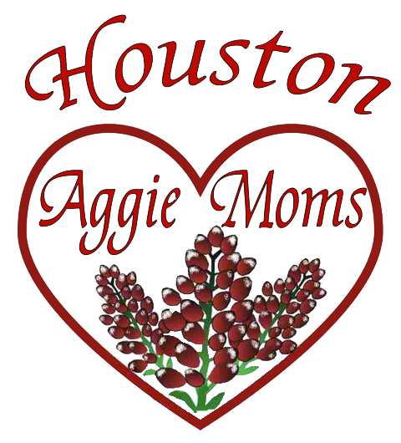

HOUSTON A&M UNIVERSITY
MOTHERS’ CLUB
BOARD OF DIRECTORS

Kathy Roth Choate
Rachel Clarke
Michelle Maresh
Michelle Rogers
Fran Marintsch
Renata DeMoes
Margo Wall
Cara Reid
Mia Sclafani
Debbie Hance
Nichole Waters
Sara Binau
Paige Herrin
Laura Bruchmiller
Pam Wright
Melissa Johnson
Laura Spilman
Maureen Storie
Denyse Ward

TAX ID #: 17460697620
houston.aggiemoms.org

October 5, 2021

Contact
Business Name
Street Address
City, State Zip

Howdy Contact,

The Houston A&M University Mothers’ Club is a member of the Federation of Texas A&M University Mothers’ Clubs, formed in 1922 when six mothers came together to deliver fried chicken dinners to their “boys” once a month. Houston Aggie Moms’ Club in this 94th year has more than 400 members and donated over $2,000,000 in student scholarships and gifts to special programs of the University. We are excited to hold our annual gala at a new venue, The Heights Villa, on February 5, 2022. This highly anticipated event with dinner, dancing, live and silent auctions, fun wine and jewelry “pulls” is our primary fundraiser! With so many new challenges facing students, their families, and the many programs we help support, the funds we generate this year for scholarships and programs at Texas A&M will fill even greater needs.

We need your help! Please consider supporting our efforts with a donation and your attendance. Your donation of items, gift cards, services and/or a monetary donation has a significant impact on this event. Bidding is LIVE online for the entire Aggie Nation and our vast network of non-Aggie friends and family members to easily participate! Your donation will be recognized on our website, in our auction program, at our well attended HAMC gala and monthly meetings.

The Houston Aggie Moms hope you will consider joining us in our efforts to support this wonderful institution and its legacy in creating the best graduates and alumni ever. Questions?Contact Sara Binau at 713 553-0993 SaraBinau2021@gmail.com.

Thanks and Gig’em,

Sara Binau and Paige Herrin
2021-2022 “Houston Aggie Moms’ Club” Auction Co-Chairs

The Houston A&M University Mothers’ Cub is a non-profit 501(c)(3) public charitable organization; your donation will be tax deductible to the extent allowed by law.

