Houston Texas A&M University Mothers’ Club
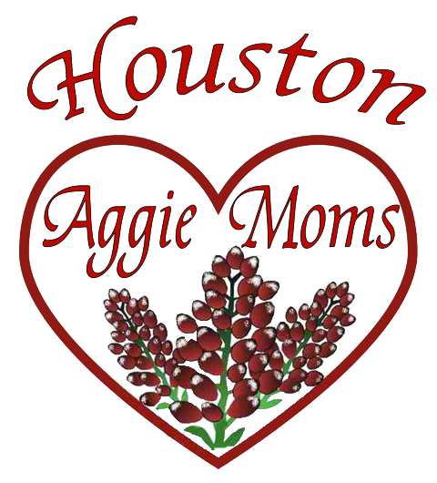
Finals Care Package Order Form
2022-2023

Care Packages may only be purchased by current members of the Houston Aggie Moms Clubs
Order Deadline for Fall 2022 – Monday, October 24, 2022
Care packages will include various Aggie-themed items and snacks
Food items are purchased in bulk & may contain allergens.
Requests for non-standard packages will not be accommodated
Students must carefully review food content labels before consumption

Available Pick-up – TAMU Hotel & Conference Center (177 Joe Routt Blvd)
December 2nd 10:00 am – 3:00 pm
Galveston orders will need to be picked up from the Care Package Coordinators in Houston

**Students should mark their calendars & watch for email changes and reminders**
Any package not picked up will be donated!!

$35 per semester or $60 for both semesters
Please Check: ______Fall package _______Spring Package Total Due: $_________
Make check payable to: Houston A&M University Mother’s Club:
Additional information and online orders are available at www.houston.aggiemoms.org/finals-care-packages
Questions: carepackages@houstonaggiemoms.org

Student Name: _________________________________ Cell: _____________________
Email: _________________________________
Parent Name: __________________________________ Cell: ______________________
Email: _________________________________

Write a personal message to your student. It will be attached to the care package

Fall 2022
To: From:

Spring 2023
To: From:

